Heron's Formula
# Source: AI Source: Provided by: [Data Path: Persons Table -> ID Column: 1, Name_En Column: Motasem Essam] -> From: [ChatGPT] on [7/25/2026]
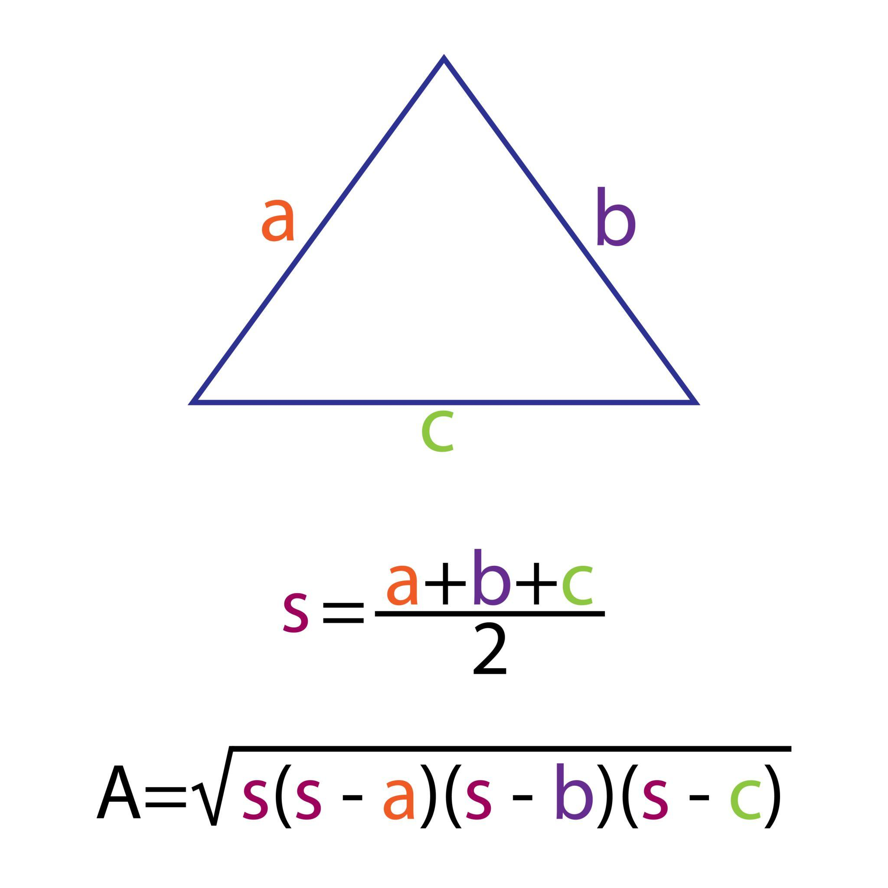
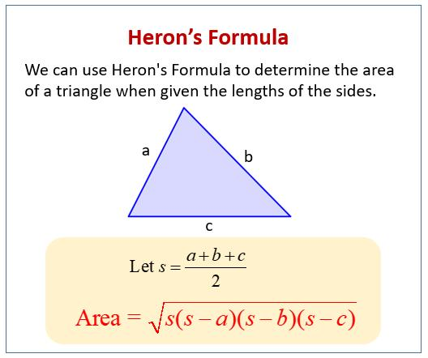
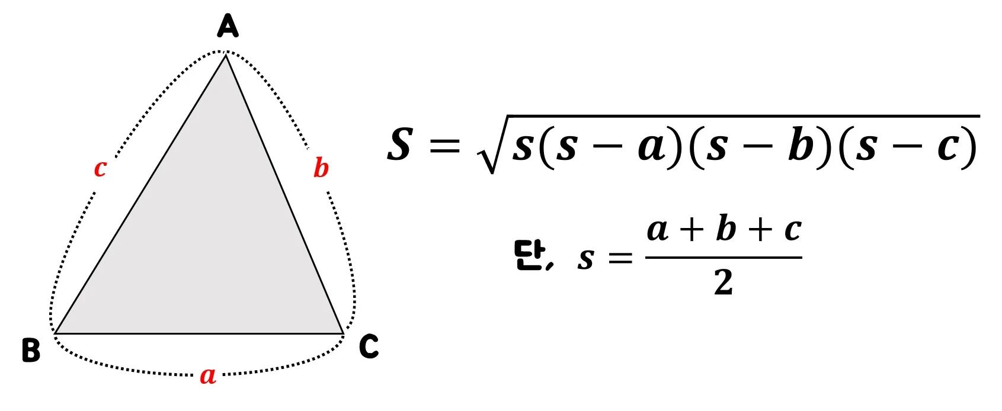
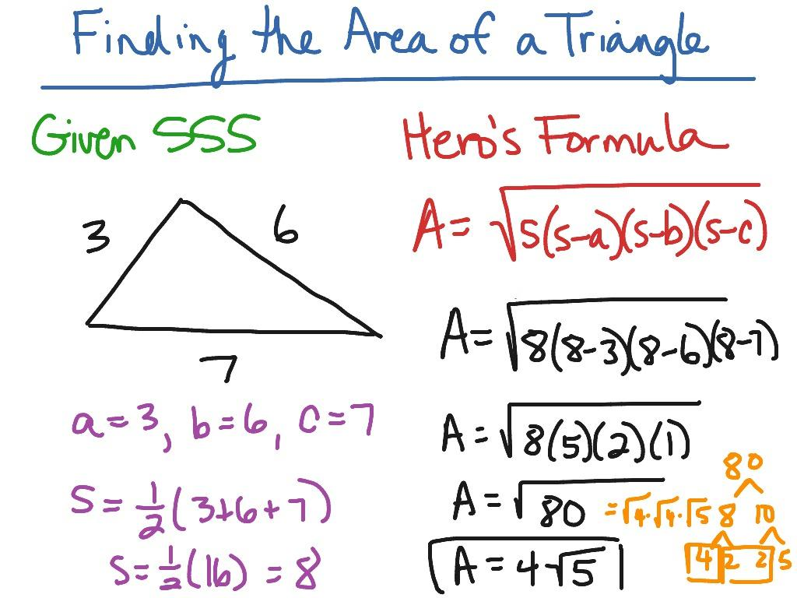

Definition
# Source: AI Source: Provided by: [Data Path: Persons Table -> ID Column: 1, Name_En Column: Motasem Essam] -> From: [ChatGPT] on [7/25/2026]
Heron's Formula is a formula used to calculate the area of a triangle when the lengths of all three sides are known.
For a triangle with side lengths $a$, $b$, and $c$, first calculate the semiperimeter $s$:
$$s=\frac{a+b+c}{2}$$
Then the area $A$ is:
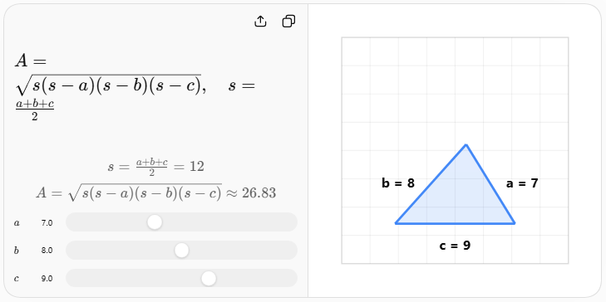

Purpose
# Source: AI Source: Provided by: [Data Path: Persons Table -> ID Column: 1, Name_En Column: Motasem Essam] -> From: [ChatGPT] on [7/25/2026]
Heron's Formula is useful when:
- All three side lengths are known.
- The height of the triangle is not known.
- The angles are not known.
- You need the area directly from side measurements.
- You are working with scalene triangles where the usual base-height method is inconvenient.

Fundamental Elements
# Source: AI Source: Provided by: [Data Path: Persons Table -> ID Column: 1, Name_En Column: Motasem Essam] -> From: [ChatGPT] on [7/25/2026]
Heron's Formula uses four main quantities:
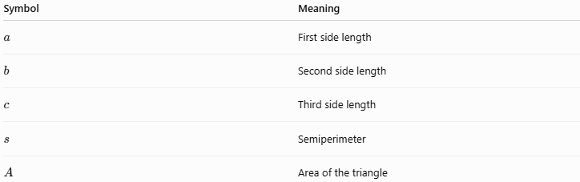
Symbol | Meaning
$$a$$ | First side length
$$b$$ | Second side length
$$c$$ | Third side length
$$s$$ | Semiperimeter
$$A$$ | Area of the triangle
The semiperimeter is:
$$\boxed{s=\frac{a+b+c}{2}}$$
The area is:
$$\boxed{A=\sqrt{s\left(s-a\right)\left(s-b\right)\left(s-c\right)}}$$

How to Use Heron's Formula
# Source: AI Source: Provided by: [Data Path: Persons Table -> ID Column: 1, Name_En Column: Motasem Essam] -> From: [ChatGPT] on [7/25/2026]
Step 1 — Identify the three sides
Suppose:
$$a=5, b=6, c=7$$
Step 2 — Calculate the semiperimeter
$$s=\frac{5+6+7}{2} \\ s=\frac{18}{2}=9$$
Step 3 — Substitute into Heron's Formula
$$A=\sqrt{9\left(9-5\right)\left(9-6\right)\left(9-7\right)} \\ A=\sqrt{9\left(4\right)\left(3\right)\left(2\right)} \\ A=\sqrt{216} \\ \boxed{A=6\sqrt{6}}$$
Therefore:
$$\boxed{A≈14.70}$$
square units.

Triangle Inequality Requirement
# Source: AI Source: Provided by: [Data Path: Persons Table -> ID Column: 1, Name_En Column: Motasem Essam] -> From: [ChatGPT] on [7/25/2026]
Heron's Formula applies to a valid triangle, so the three side lengths must satisfy the triangle inequality:
$$\boxed{a+b>c} \\ \boxed{a+c>b} \\ \boxed{b+c>a}$$
Equivalently:
$$\boxed{∣a-b∣<c<a+b}$$
If these conditions are not satisfied, the three lengths cannot form a nondegenerate triangle.

Special Case — Right Triangle
# Source: AI Source: Provided by: [Data Path: Persons Table -> ID Column: 1, Name_En Column: Motasem Essam] -> From: [ChatGPT] on [7/25/2026]
For a right triangle, Heron's Formula still works.
For example, consider a $3$-$4$-$5$ triangle:
$$a=3, b=4, c=5$$
The semiperimeter is:
$$s=\frac{3+4+5}{2}=6$$
Therefore:
$$A=\sqrt{6\left(6-3\right)\left(6-4\right)\left(6-5\right)} \\ A=\sqrt{6\left(3\right)\left(2\right)\left(1\right)} \\ A=\sqrt{36} \\ \boxed{A=6}$$
This agrees with the ordinary right-triangle area formula:
$$A=\frac{1}{2}\left(3\right)\left(4\right)=6$$

Special Case — Equilateral Triangle
# Source: AI Source: Provided by: [Data Path: Persons Table -> ID Column: 1, Name_En Column: Motasem Essam] -> From: [ChatGPT] on [7/25/2026]
For an equilateral triangle:
$$a=b=c$$
Let the side length be $a$.
Then:
$$s=\frac{3a}{2}$$
Substituting into Heron's Formula gives:
$$A=\sqrt{\frac{3a}{2}\left(\frac{a}{2}\right)\left(\frac{a}{2}\right)\left(\frac{a}{2}\right)}$$
which simplifies to:
$$\boxed{A=\frac{\sqrt{3}}{4}a^{2}}$$
Thus, Heron's Formula produces the standard equilateral-triangle area formula.

Relationship with the Semiperimeter
# Source: AI Source: Provided by: [Data Path: Persons Table -> ID Column: 1, Name_En Column: Motasem Essam] -> From: [ChatGPT] on [7/25/2026]
The semiperimeter is fundamental to Heron's Formula:
$$\boxed{s=\frac{P}{2}}$$
where $P$is the perimeter.
Since:
$$P=a+b+c$$
we have:
$$\boxed{s=\frac{a+b+c}{2}}$$
Heron's Formula can therefore be viewed as an area formula based entirely on the three sides and their semiperimeter.

Relationship with the Base-Height Formula
# Source: AI Source: Provided by: [Data Path: Persons Table -> ID Column: 1, Name_En Column: Motasem Essam] -> From: [ChatGPT] on [7/25/2026]
The ordinary triangle area formula is:
$$A=\frac{1}{2}bh$$
This requires a base $b$and its corresponding height $h$.
Heron's Formula instead requires only:
$$a, b, c$$
So:
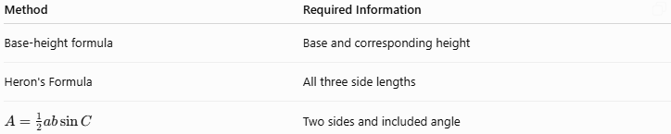
Method | Required Information
Base-height formula | Base and corresponding height
Heron's Formula | All three side lengths
$$A=\frac{1}{2}ab\sin{C}$$ | Two sides and included angle

Relationship with the Law of Cosines
# Source: AI Source: Provided by: [Data Path: Persons Table -> ID Column: 1, Name_En Column: Motasem Essam] -> From: [ChatGPT] on [7/25/2026]
Heron's Formula is closely related to the Law of Cosines.
The Law of Cosines can determine an angle from three sides:
$$\boxed{\cos{C}=\frac{a^{2}+b^{2}-c^{2}}{2ab}}$$
Then the area can be found using:
$$A=\frac{1}{2}ab\sin{C}$$
Heron's Formula combines this information into a direct formula using only $a$, $b$, and $c$.

Relationship with the Inradius
# Source: AI Source: Provided by: [Data Path: Persons Table -> ID Column: 1, Name_En Column: Motasem Essam] -> From: [ChatGPT] on [7/25/2026]
Heron's Formula is also connected to the triangle's inradius $r$.
The area can be expressed as:
$$\boxed{A=rs}$$
Therefore:
$$\boxed{r=\frac{A}{s}}$$
Using Heron's Formula:
$$\boxed{r=\frac{\sqrt{s\left(s-a\right)\left(s-b\right)\left(s-c\right)}}{s}}$$
which can also be written as:
$$\boxed{r=\sqrt{\frac{\left(s-a\right)\left(s-b\right)\left(s-c\right)}{s}}}$$

Advantages
# Source: AI Source: Provided by: [Data Path: Persons Table -> ID Column: 1, Name_En Column: Motasem Essam] -> From: [ChatGPT] on [7/25/2026]
- Requires only the three side lengths.
- Does not require calculating a height.
- Does not require knowing an angle.
- Works for scalene, isosceles, and equilateral triangles.
- Works for acute, right, and obtuse triangles.
- Provides an exact area when the side lengths produce an exact radical.

Limitations
# Source: AI Source: Provided by: [Data Path: Persons Table -> ID Column: 1, Name_En Column: Motasem Essam] -> From: [ChatGPT] on [7/25/2026]
- The three side lengths must form a valid triangle.
- Calculations can become cumbersome with complicated decimal measurements.
- Measurement errors in the three sides affect the calculated area.
- It is unnecessary when the base and height are already known and simple to use.

Real-World Applications
# Source: AI Source: Provided by: [Data Path: Persons Table -> ID Column: 1, Name_En Column: Motasem Essam] -> From: [ChatGPT] on [7/25/2026]
Heron's Formula can be used in:
- Land surveying.
- Construction.
- Engineering.
- Architecture.
- Geographic measurements.
- Computer graphics.
- Computational geometry.
- Calculating areas of triangular regions when only side measurements are available.

Important Related Formulas
# Source: AI Source: Provided by: [Data Path: Persons Table -> ID Column: 1, Name_En Column: Motasem Essam] -> From: [ChatGPT] on [7/25/2026]
Perimeter
$$\boxed{P=a+b+c}$$
Semiperimeter
$$\boxed{s=\frac{a+b+c}{2}}$$
Heron's Formula
$$\boxed{A=\sqrt{s\left(s-a\right)\left(s-b\right)\left(s-c\right)}}$$
Inradius-Area Formula
$$\boxed{A=rs}$$

Key Points
# Source: AI Source: Provided by: [Data Path: Persons Table -> ID Column: 1, Name_En Column: Motasem Essam] -> From: [ChatGPT] on [7/25/2026]
- Heron's Formula calculates the area of a triangle from its three side lengths.
- First calculate the semiperimeter:
$$\boxed{s=\frac{a+b+c}{2}}$$
- Then calculate:
$$\boxed{A=\sqrt{s\left(s-a\right)\left(s-b\right)\left(s-c\right)}}$$
- The three sides must satisfy the triangle inequality.
- It works for scalene, isosceles, equilateral, acute, right, and obtuse triangles.
- It is closely related to the triangle's semiperimeter and inradius.

Conclusion
# Source: AI Source: Provided by: [Data Path: Persons Table -> ID Column: 1, Name_En Column: Motasem Essam] -> From: [ChatGPT] on [7/25/2026]
Heron's Formula provides a direct method for finding the area of a triangle when its three side lengths are known. It is an important triangle-area formula because it eliminates the need to know either a height or an angle.

